Christ Church
Sowerby Bridge

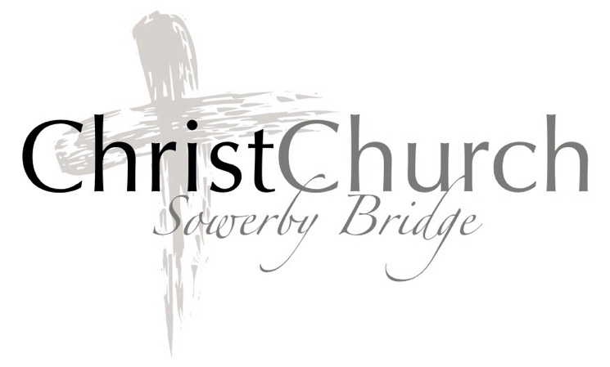

Praying for our Parish
Street by Street
2020

Praying for our Parish for 199 years

Outline of the Parish of Christ Church Sowerby Bridge
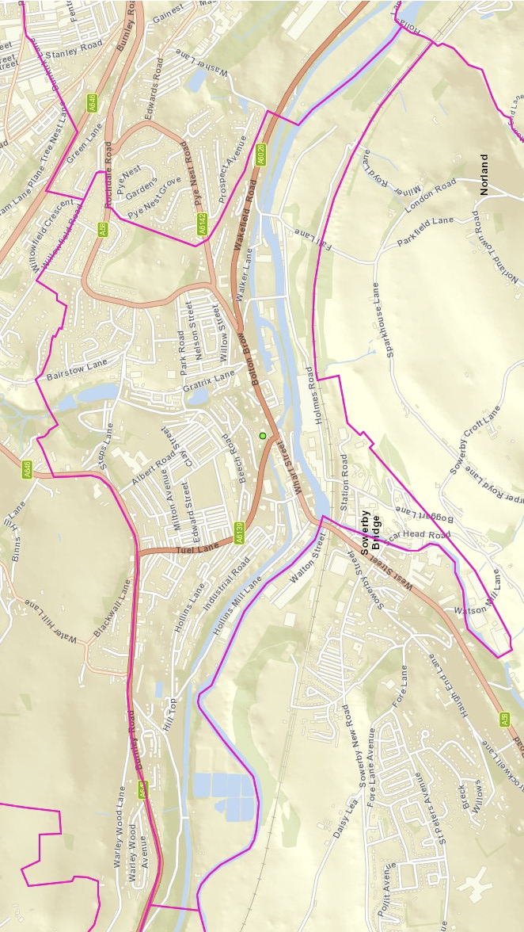

Please pray for the item and streets listed each day of the month. Pray for God’s presence in the homes (bringing to mind anyone you might know), workplaces, schools etc on the streets for each day.

1st The Vicar
The Churchwardens
The PCC
All who play a part in the running of this church
Albert Buildings
Albert Road
Albert View
Alexandra Close
Allan Park
Allan Terrace
Annie Street
Arnold Street

2nd The Bishop of Leeds
The Diocese of Leeds
Back Pleasant Street
Back Wakefield Road
Back Wharf Street
Bairstow Lane
Bairstow Mount
Baldwin Yard
Bank Road
Bank Street

3rd The Bishop of Huddersfield
The Archdeacon of Halifax
Bankfield Terrace
Beach Avenue
Beech Road
Beech View
Beech Villas
Belgrave Street
Belmont Street
Bentley Mount

4th The Area Dean
The Halifax Deanery
Bentley Mount
Boggart Lane
Bolton Brow
Bridge Street
Bright Street
Burnley Road
Byron Avenue
Byron Street

5th Pupils staff and Governors of Christ Church Junior School
Byron Terrace
Canal Road
Carlton Mill
Central Buildings
Chapel Lane
Chester House
Charles Street
Chester Street

6th Pupils staff and Governors of
Tuel Lane Infant School
Church Bank
Church View
Claremont Street
Claremont Villas
Clay Street
Clemont Street
Cleveleys Avenue
Cleveleys Garden

7th Pupils staff and Governors of
Bolton Brow Primary
Academy
Cliffe Terrace
Clifton Street
Clyde Street
Corporation Street
Croft Street
Crow Wood Park
Daisy Mount
Dale Street

8th Pupils staff and Governors of
Trinity Academy,
Sowerby Bridge
Dale Terrace
Dale View
Dalton Street
Dam Head Road
Dearden Street
Denby Place
Derby Street
Durham House

9th HM The Queen
Members of the Royal Family
Eaglescliffe
East Parade
East View
Ediths View
Edward Street
Egerton Street
Elm Avenue
Elm Place

10th Our Local MP
Our Prime Minister
Members of Parliament
Exeter Street
Fairbanks
Fall Lane
Fern Lea Street
Gas Works Road
Gratix Lane
Greenups Mill
Greenups Terrace

11th Ward Councillors
Calderdale Council
Grove Street
Greenside Gardens
Hanover Street
Height Green
High Fields
Hill Crest
Hill Crest Avenue
Hill Top

12th Minister and congregation of
St. Pauls Methodist Church
Hollas Lane
Hollins Bank
Hollins Bungalows
Hollins Lane
Hollins Mill Lane
Holmes Road
Hope Street
Houghton Towers

13th The Priest and Congregation of
St. Patricks Catholic Church
Industrial Road
John Street West
Ladstone Towers
Langton Street
Laurel Mount
Leigh Street
Lime Tree Court
Linden Place

14th The Pastor and congregation of Elim Pentecostal Church
Lord Street
Lower Clifton Street
Lower Clyde Street
Lower Hollins
Malton Street
Marina Gardens
Marton Heights
Mayfield Gardens

15th Christians Together
Sowerby Bridge
Any Church you have
connections with
Mearclough Road
Milner Royd Lane
Milton Avenue
Milton Place
Milton Street
Mitchell Street
Mount Street
Myrtle Terrace

16th All who live & work within
the Parish
Nelson Place
Nelson Street
New Marsh
Newton Street
Newton Terrace
Norland Road
Norland View
North Lea

17th For all on our prayers needed list
Oak Avenue
Oak Place
Oak Street
Old Cawsey
Old Marsh
Oliver Close
Orion Place
Overdale Mount

18th For Mothers Union
Oxford Street
Park Crescent
Park Drive
Park Gardens
Park Road
Park Street
Park View
Park Villas

19th Rainbows, Brownies and Guides
Patricia Gardens
Peel Street
Persverance Street
Plainfield
Plane Tree Road
Pleasant Street
Poplar Avenue
Princess Street

20th Street Angels
Pub’s and clubs within
the Parish
Pye Nest Road
Recreation Road
Regent Parade
Regent Place
Rochdale Road
Rose Grove
Rose Grove Lane
Rose Hill

21st For the needs of our church
Rosevale View
Saffron Close
Scar Head Road
Smiths Yard
South View
Spring Bank
Spring Garden
Spring Terrace

22nd For the future of our church
St Anns Square
Stanley Street
Station Approach
Station Road
Steps Lane
Stonecroft Mount
Summerland Terrace
Sunny Bank Drive

23rd For growth of our church family
Sunny Bank Street
The Banks
The Canal Basin
The Hollies
The Meadows
Timmey Lane
Tower Hill
Town Hall Court

24th Give thanks for what God
has provided
Town Hall Street
Tuel Lane
Union Street
Upper Bolton Brow
Upper Fountian Street
Victoria Avenue
Victoria Road
Victoria Street

25th Our Country and the world
Villa Street
Wakefield Road
Walker Lane
Wallis Street
Washer Lane
Water Street
Watson Bridge

29th –31st For the Church of England, our Archbishops and Overseas Links
For the shops and businesses within the parish
Areas outside the Parish, where members of our congregation live,
including;
Blackshaw Head, Bradshaw, Burnley, Halifax, Holmfield, Illingworth, King Cross, Norland, Norton Tower, Northowram, Ovenden, Pye Nest, Rishworth, Triangle, Todmorden, Warley, Wheatley

26th For the Environment
Watson Mill Lane
West Parade
Wharf Street
Willow Crescent
Willow Dean Avenue
Willow Gardens
Willow Hall Drive

27th For people known to us
Willow Hall Fold
Willow Hall Lane
Willow Houses
Willow Street
Willow Terrace
Willow View
Willowfield Avenue

28th Ourselves
Our Family
Our Friends
Willowfield Drive
Willowfield Road
Wood Nook Grange
Wood Nook Lane
Woodlands Drive
Woodroyd
Woodroyd Gardens

The Lords Prayer

Our Father in heaven,
Hallowed be your name,
your kingdom come,
your will be done,
on earth as in heaven.
Give us today our daily bread.
Forgive us our sins
as we forgive those who sin
against us.
Lead us not into temptation
But deliver us from evil.
For the kingdom, the power, and the glory are yours
now and for ever.
Amen.

This space is for you to write down anything you would like to pray for.

Prayer for Growth

God of mission,
who alone brings growth
to you Church,
send your Holy Spirit to give
vision to our planning,
wisdom to our actions,
and power to our witness.

Help our church to grow in
numbers, in spiritual
commitment to you,
and in service to our
local community, through
Jesus Christ our Lord.
Amen

Items for prayer from our monthly ‘Half Hour of Prayer’ meeting
(usually 4th Saturday of the month at 11.30am)

Items for prayer

Giving Thanks.
- For answered prayer in all situations.
- For God’s goodness to us.
- Other items to give thanks.

Pray for the needs of our Church.
- That God would continue to be generous towards us as we are generous to our church. We ask particularly that our cashflow is kept buoyant throughout the winter months when there are more demands from us on the utility bills.
- That we are all encouraged by the Diocesan Vision to become confident Christians, living, loving and learning together.
- That God would guide all hearts and minds to find ways to pay our Parish Share to the Diocese (just over £25,500).
- For the financial resources to meet the upgrade that is needed in our sound system.
- For every member to engage with God’s call to be a beacon of hope in the community.
- That we will be fully equipped to act as a Crisis Centre should we be needed.
- That God would show us ways of getting out of deficit with our monthly finances.
- That you would prompt us Lord, to give generously where we have the means.
- For the PCC, Churchwardens and the Vicar.

Pray for our community
- That our relationship with St. Paul’s and other churches in Sowerby Bridge will continue to grow and that we follow God’s will as we seek to make a difference together in Sowerby Bridge.
- That as we journey through the year that there will be safety on our roads and protection from adverse weather conditions, particularly with risk of flooding.
- That our town would be a safe place for all.
- That the young people in our town may be provided with resources to become positive citizens.
- That the community police would be given the resources to do their jobs effectively.
- That the community would work together for the good of the town.

Pray for the vision for the future of the church
- That our fundraising efforts will bear fruit and resource the Good News of the Gospel that we wish to share.
- That as a whole church we reflect on our purpose and function as disciples on the Pilgrim Way of Christ.
- That we as a church may live as people of hope for knowing the risen Christ.
- That the Lord would guide us as we look to the future use of this building and stewardship of our resources. That more agencies will want to use the resource we have.
- That the Lord would give us a clear vision for our church and the role of our building.
- For the reality of what it means to be a church member begins to reach home in all of our hearts.
- That all members would find their place in church life where gifts and skills will be used to good effect.
- That individual members seek to grow in discipleship.
- That the whole church will engage with its future mission in our community.
- That God would increase our number at Christ Church bringing people who are thirsty to know more about Jesus and become true disciples.
- That we would be a church that works to meet the needs of the community we serve and sharing the good news.
- For the ‘Street Angels’ team here and in Halifax to continue to be effective as they continue their work.
- For the Vicar to find time and space to spend time with God.

Pray for the growth of our church family
- That we might know the power of the Holy Spirit in all that we do.
- that we will grow in faith
- that we will develop strong and lasting relationships.
- that we will together want to learn more about Jesus and his Word and his role in our lives.
- For new faces in church that they will feel the presence of Jesus and want to keep coming.
- For those who are missing from church, that they might feel the need to be with their church family.
- For those who can’t get to church because of ill health, that we may keep contact and involvement with them.
- For our Junior Church. That Fiona and her team will continue to be given the energy to effectively guide and teach our young people through the power of the Holy Spirit. That our young people grow stronger and stronger in their faith.
- For our Uniformed groups that they would thrive under the Christian Leaders that serve them and that God would bless all their efforts to provide all that they need.
- For Peter H and those who accompany him on pastoral visits to take communion to our housebound members.

Mothers’ Union
- Give thanks for Mothers’ Union worldwide and for our branch.
- Pray for the World Wide president - Mrs Sheran Harper in Guyana that God would guide her and bless her with wisdom.
- Pray for Jean Thurman (Diocesan President) and her team.
- For our Area President, Elaine Swinhoe.
- Pray that local and international projects will thrive.
- Pray for all those who suffer from gender based violence that they may be protected and able to have safe places to go.
- Pray for our own branch that we will be able to sustain it here in Sowerby Bridge and for our Indoor Members.
- Give thanks for new members and pray that more would join.
- Pray for Justine Helliwell our branch leader.

Pray for Christ Church School
- That the whole school is excited for a term of learning together.
- Pray for God’s protection for a positive reputation for our school.
- For the school budget that God would provide all that is needed to sustain teaching and learning in the school and impact on progress and attainment.
- For the mission statement: Growing in faith, learning and love. That the school would continue to build a strong Christian Ethos throughout.
- For the Christian Values – (Friendship, Trust, Koinonia, Wisdom and Endurance).
- For our Head (Alison Embleton)as she returns from maternity leave.
- Acting Head(Alison Firth) we thank you for the work she has done and pray that she may continue to leadership of our school and be confident in the support she is given.
- For Ester Mor as acting deputy that she and Alison F. will make a strong leadership team.
- For the Administrative Staff (Anthea Gee and Sheila Ryder) that they are able to do their jobs effectively and as the first point of contact continue to give a cheerful welcome to all who come to the door.
- For Anthea's role as School Business manager that God would give her the time and space to deal with the complexities of school finance with the constant government changes and initiatives.
- For new staff that they enjoy working at Christ Church and settle in well.
- For all the staff that they all really love working in our school.
- For the strong relationship with Tuel Lane infants and closer working together over the next few years.
- For parents to co-operate and support the ethos of the school.
- for God's blessing and protection.
- For the governors that they might give the right level of support and challenge.
- For more governors please.
- For the other schools in our Parish – Bolton Brow and Trinity Academy, Sowerby Bridge as we seek to make closer ties.
- For our family members and friends who work in Education.

Pray for our Diocese of Leeds
- The Bishop of Leeds – Bishop Nick Baines.
- Archbishop of Canterbury - Justin Welby
- Archbishop of York – John Sentamu
- Our area bishops:
- Bishop Tony Robinson (Wakefield)
- Bishop Jonathan Gibbs (our Bishop of Huddersfield)
- Bishop Toby Howarth (Bradford)
- Bishop Helen-Ann Hartley (Ripon)
- Bishop Paul Slater (Richmond and Craven)
- Archdeacons Peter Townley (Pontefract); Anne Dawtry (Halifax); Andy Jolley (Bradford); Paul Hooper (Leeds); Jonathan Gough (Richmond and Craven)
- Area Dean(s) – Kathia Shoesmith and Marion Russell
- We pray for Her majesty the Queen as head of the church and the Royal Family.
• The Vicar – Angela
- That we may all seek to work together to share resources, pay our way and reach out to our communities with the Gospel and sharing Christ's love in practical ways.
Pray for the Earth and our Environment
[The PCC are supporting the ‘Diocesan Environmental Strategy’ and have signed up to being an ‘Eco Church.’
- We reflect on our stewardship of God’s creation using the Prayer for Earth Day :

All: “Sovereign Lord, you are the creator and sustainer of the earth and you have given us dominion over its resources: Forgive us for squandering your gifts, Inspire us to conserve them, and use them aright in the service of your people, and to the glory of your name; Through Jesus Christ our Lord.”

We pray for:
- The changes in our climate: extremes of drought and famine; rising seas and floods, and the impact on all species, habitats and communities who are the most affected
- Those working to reduce harmful impacts of human consumption such as pollution, de-forestation and extinction due to our greed, and inability to share
- The beauty of your creation from the wild landscapes for endangered species to our local parks, nature reserves, gardens and our own churchyard in Sowerby Bridge
- We pray for Change, so the earth you created is, once again, seen as good for all living things.

Seasonal
- For God’s presence with us through the church year Advent, Christmas, Epiphany, Lent, Easter, Pentecost, Trinity, Ordinary Time, Harvest Thanksgiving, Remembrance, Christ the King. May all that is done in this place and in our lives be for the glory of God and strengthening of our relationships.
Pray for our country and the world
- Praying for our Town and others in the Calder Valley that they would thrive economically and socially.
- We thank you for our Mayor N., we pray she/he will have a very effective and rewarding year.
- For our government and the Prime Minister N. and all those in the political arena that they will unite to work for the good of all people in our nation.
- For the political climate: We pray for peace between divided communities, and within families, we pray for peace between political opponents. We pray that You would be our refuge and our strength. Our mighty fortress in times of need. Lord keep our focus on you, and as we hear and think about politics we would seek to serve and worship you. Amen.
[Evangelical Alliance]
- our leaders/politicians – that in these difficult, messed up days they will seek to work together irrespective of party politics to secure a united nation.
- For the Queen as head of state and the Royal family – that they will look to the Lord for guidance and strength.
- An end to acts of terrorism – let us bring to mind all the events and incidents we are faced with as a worldwide community throughout the world and recent news - pray that our communities will unite in the fight against terrorism, fake news and divisive policies rather than divide.
- We pray for other areas of the world where natural disaster has caused devastation.
- the economy to improve and austerity decrease
- peace and unity in our towns and cities
- peace in war torn areas of the world – deliver us from evil
- that those who are hungry will be fed
Praying for ourselves
- For the power and protection of the Holy Spirit in our lives
- For those in our church and community who need our prayers for healing and peace.
- For family and friends
- Anything that you want to bring before the Lord
- The bereaved

