Christ Church Sowerby Bridge - Prayer walk
Please enjoy sitting on a bench & if you wish, use this prayer walk along the path in front of the church, to pray for the town
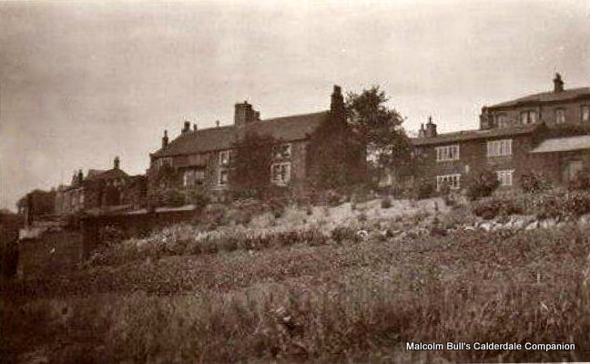
- Facing the main entrance, turn left. Stop at the end & look along the back of the church up the hillside. There is a walled- in outline of the entrance for an old footpath leading to “The Bache.” This house was owned by Timothy Bates who used to walk down from his house, through the allotments known as “Pollit Fields” and into the new church building which was built partly on his land in 1821. His son George, and subsequently his grandson Joseph Pollit inherited the estate in 1859. Rev Charles Rogers, Vicar of Christ Church from 1829-1863 married into the Pollit family and the building was used as a separate meeting place for the children’s Sunday school. This picture of the hillside between the church and “The Bache” was taken in the 1920s. “The Bache” was renamed Beech House (A) and became the home of Eustace Wigzell as noted on his memorial. In 1963 a new footpath was created outside the graveyard wall when the allotments became the site of tower blocks. These were demolished in 2017/18.
Pray for everyone who lives in the Parish: families at home self isolating; those who live alone or are in residential homes in need of care; and for those with no home or worried about paying their bills.

- Look ahead, facing Tuel Lane and you will see the Pollit and Wigzell Memorial slightly to your right.
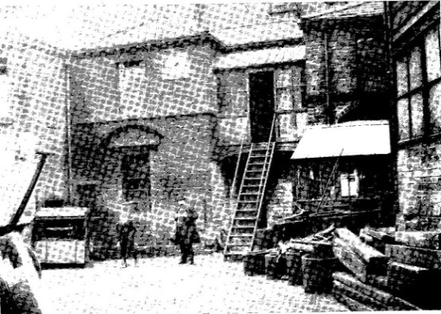
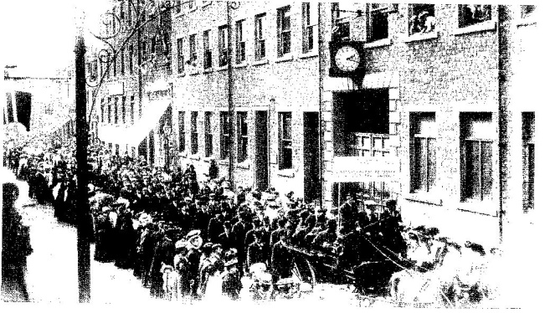
The joint memorials to Edward Ernest Pollit and Eustace Wigzell were erected on this spot overlooking the site of their engineering works - Pollit & Wigzell. The works developed out of and alongside the original Bank Foundry established by Timothy Bates in 1786 at the start of the industrial revolution. The original buildings spanned the canal with an entrance off Tower Hill (which was the main route into Sowerby Bridge before the re-alignment of Tuel Lane). (C)

The Works on Wharf St c1906, and behind, the original Foundry yard c1910
The engineering factory itself faced onto Wharf Street – the whole site occupying an area of 5 acres. By the late 19th century the engineering works and foundry employed over 500 people and made steam engines exported throughout the British Empire. It closed in 1931 when steam was overtaken by modern technology and was demolished in 1937. The site of the factory is now Regent Parade, housing shops. The foundry site is now LIDL and the open market’s car park.
Pray for all the businesses in town: those working in shops and banks; those trying new ways to keep their business afloat: “on –line” or “self- service / take away”; and those suddenly without work or worried about their livelihood in the future.

- Walk across the front of church graveyard stopping by the old font at the top of the disused path from Wharf Street
The “table top” gravestones are typical of the Georgian and early Victorian era but the high mortality rate at the time meant that Christ Church graveyard, first used for burials in May 1821, was closed in 1857 by order of Queen Victoria. 1730 people had been buried here before a new cemetery off New Road was opened by the local Board of Health.

Pray for those in the emergency services, particular those caring for those with COV-ID19 , and not forgetting all those in hospital with other critical illnesses and conditions. May they be kept safe to continue caring for the sick & dying. Pray for those providing care for school children to allow those in special occupations to work, and that vulnerable children are supported.

- Return to the top of the entrance path to look back to road
This spot gives the best endorsement of the value of a conservation area. The open view across the road to the canal, with the railway in the distance is still recognisable as the source of wealth in Victorian Sowerby Bridge. Today the cars have replaced the electric tram and the road is the busiest route, but these three important transport links were fundamental to the success of business in the town. Conservation work in the 1990s to reinstate two former locks (nos. 3 and 4) into the deepest one in England (Sowerby Bridge Tuel Lane Deep Lock) re-opened the link between the Rochdale canal and the Calder and Hebble Navigation for travel between Hull and Liverpool. The canal basin was restored to provide moorings and the warehouses for new business use. (D)

Pray for those working in transport & logistics networks to provide essential supplies to shops, hospitals, etc. and those in crisis planning & communications. We encourage everyone to do as Jesus taught: to take care of their neighbour so nobody feels isolated or alone.

We end the prayer walk by sharing the Blessing “Go in peace, to love and serve the Lord”. We hope you feel at peace and refreshed by your visit here. PLEASE GIVE US FEEDBACK via info@christchurchsb.org.uk or our facebook page where you can find out more about the church.

